BUSINESS INTELLIGENCE DASHBOARD ANALYSIS USING POWER BI

1. Business Scenario / Background
In today's competitive business environment, organizations generate vast amounts of customer and company-related data. Analyzing this data manually is challenging and often leads to missed opportunities for strategic decision-making. Business Intelligence (BI) tools such as Power BI enable organizations to transform raw data into meaningful insights through interactive dashboards and visual analytics.
This project focuses on developing a Business Intelligence Dashboard using Power BI to analyze customer, company, industry, revenue, and engagement data. The dashboard helps organizations understand customer distribution, identify industry trends, monitor business performance, and improve decision-making processes. Through various visualizations, stakeholders can gain a comprehensive understanding of business operations and customer behavior.

2. Business Objectives
The primary objectives of this project are:
- To analyze organizational and customer-related data.
- To study industry-wise account distribution.
- To evaluate annual revenue distribution across departments.
- To identify dominant professional roles within organizations.
- To analyze customer engagement using email activity.
- To understand geographical distribution of customers.
- To support strategic business decision-making through data visualization.
- To provide actionable insights using Power BI dashboards.

3. Key Performance Indicators (KPIs)
The dashboard measures the following Key Performance Indicators:
Total Accounts
Represents the total number of customer accounts available in the dataset.
Industry Distribution
Shows the percentage contribution of different industries.
Revenue Distribution
Measures annual revenue information across various departments.
Professional Title Distribution
Analyzes the number of contacts based on organizational roles.
Email Engagement
Tracks customer interactions through email open activities.
Geographic Presence
Displays customer distribution across different cities.

4. Dataset Overview
The dataset contains approximately 47,577 records and 42 attributes related to organizations, employees, and customer engagement.
Major Columns Used in the Dashboard
- Apollo Account ID
- First Name
- Last Name
- Company
- Industry
- Department
- Title
- Annual Revenue
- Email Opens
- Company City
- Company State
- Company Country
- Number of Employees
- Revenue Range
- Website
The dataset was imported into Power BI after performing necessary cleaning and transformation activities.
Data Preparation
The following preprocessing steps were performed:
- Removed duplicate entries.
- Checked and handled missing values.
- Standardized industry names.
- Corrected formatting inconsistencies.
- Verified data types.
- Prepared data for visualization.

5. Business Questions
The dashboard was designed to answer the following questions:
- Which industries have the highest number of customer accounts?
- How are customer accounts distributed across industries?
- Which departments contribute the most revenue-related records?
- What are the most common professional titles?
- Which cities show higher customer engagement levels?
- How can customer behavior be monitored effectively?
- What insights can support business growth and planning?

6. Exploratory Data Analysis (EDA)
Exploratory Data Analysis was conducted to identify patterns, trends, and relationships within the dataset.
Industry Analysis
The industry analysis indicates that Information Technology & Services is the largest sector represented in the dataset. Construction, Real Estate, Financial Services, and Marketing & Advertising also contribute significantly.
Revenue Analysis
Revenue information is concentrated among executive-level departments and operational units. Larger organizations contribute a substantial portion of the annual revenue records.
Professional Role Analysis
The majority of records belong to senior management positions such as Presidents, Vice Presidents, CEOs, and Owners, indicating that the dataset focuses primarily on organizational decision-makers.
Geographic Analysis
Customer records are distributed across numerous cities, demonstrating broad geographical coverage and market reach.
Email Engagement Analysis
Email engagement data provides insights into customer responsiveness and communication effectiveness.

7. Dashboard Visualizations
7.1 Industry-wise Account Distribution
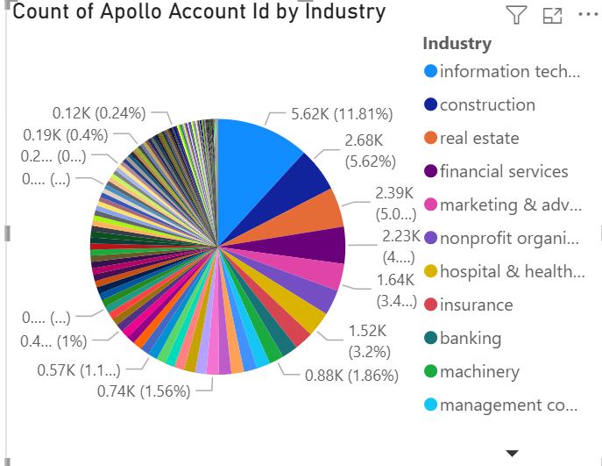
Description
The pie chart displays the distribution of customer accounts across various industries. Each segment represents the proportion of accounts belonging to a specific industry.
Analysis
Information Technology & Services has the largest share of customer accounts. Construction and Real Estate industries follow, indicating strong representation from these sectors. Financial Services and Marketing industries also contribute significantly.
Findings
- Information Technology & Services contributes the highest number of accounts.
- Construction and Real Estate represent major business sectors.
- The dataset covers a wide variety of industries.
- Industry diversity reflects broad business engagement.

7.2 Annual Revenue Distribution by Department
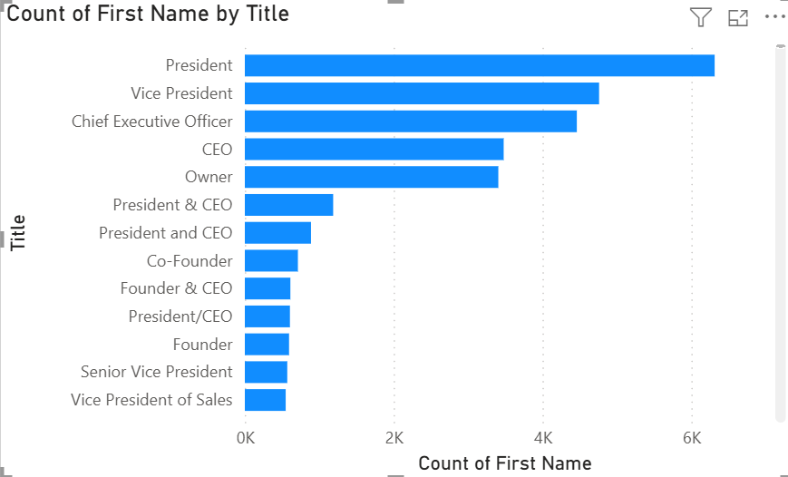
Insert Clustered Bar Chart Here
Description
The clustered bar chart displays the distribution of annual revenue records across various organizational departments. It helps compare the contribution of each department based on the number of annual revenue entries available in the dataset.
Analysis
The chart shows that the Unknown Department category contains the highest number of annual revenue records, followed by C-Suite, Operations, Sales, and Marketing departments. This indicates that executive-level and operational departments contribute significantly to business activities.
The visualization allows easy comparison between departments and highlights the areas where organizational resources and business activities are concentrated.
Key Findings
- Unknown Department contains the highest number of revenue-related records.
- C-Suite executives represent a significant portion of organizational activities.
- Operations and Sales departments contribute considerably to business performance.
- Revenue distribution varies across departments, indicating differences in organizational responsibilities.
- Executive and operational departments play a major role in business growth.

7.3 Professional Title Analysis
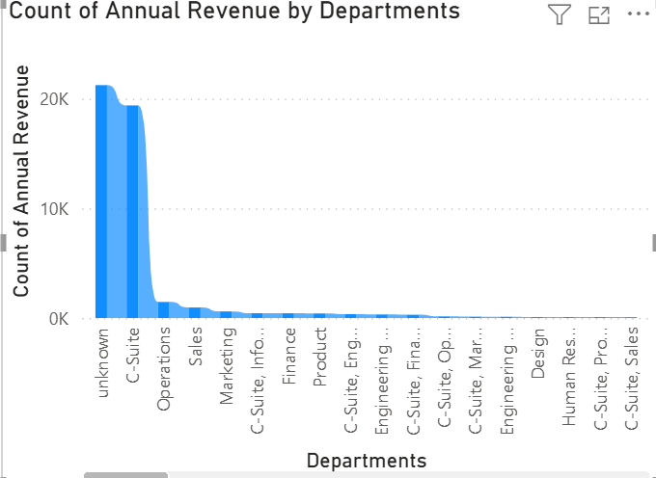
Description
The clustered column chart illustrates the distribution of individuals based on their professional titles within different organizations. The chart compares the number of contacts associated with each designation and highlights the most common leadership roles present in the dataset.
Analysis
The chart reveals that President is the most frequently occurring title in the dataset, followed by Vice President, Chief Executive Officer (CEO), Owner, and Founder positions. This indicates that the dataset primarily consists of senior-level professionals and key decision-makers across various industries.
The visualization helps identify the organizational hierarchy and demonstrates the strong presence of executive and leadership roles within the customer base.
Key Findings
- President is the most common professional title in the dataset.
- Vice Presidents and Chief Executive Officers constitute a significant portion of the records.
- Owners, Founders, and Co-Founders are also highly represented.
- The dataset is largely composed of senior management and decision-making personnel.
- Leadership positions dominate customer and organizational records.

7.4 Email Engagement by Company City
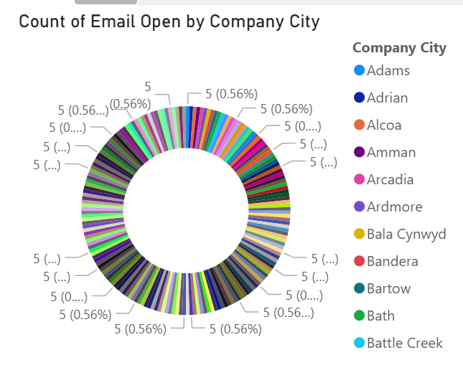
Description
This chart shows customer email engagement across different cities.
Analysis
Customer interactions are distributed across multiple locations, with major metropolitan cities contributing the highest engagement levels.
Findings
- New York contributes the highest engagement activity.
- Chicago, Los Angeles, and San Francisco also show strong participation.
- Customer engagement is geographically diversified.
- Email metrics help evaluate communication effectiveness.

8. Key Insights
The dashboard analysis revealed several important insights:
- Information Technology & Services is the dominant industry.
- Executive-level professionals account for the majority of customer records.
- Revenue activities are concentrated among leadership and operational departments.
- Major cities contribute significantly to customer engagement.
- Business activities are spread across multiple industries and regions.
- Customer engagement patterns provide valuable business intelligence.

9. Recommendations
Short-Term Recommendations
- Improve customer segmentation strategies.
- Monitor engagement levels regularly.
- Enhance data quality management practices.
- Analyze high-performing industries in greater detail.
- Improve classification of unknown department entries.
Long-Term Recommendations
- Implement predictive analytics for customer behavior analysis.
- Develop advanced business intelligence models.
- Integrate machine learning techniques for forecasting.
- Create automated reporting systems.
- Build real-time monitoring dashboards.
- Enhance customer relationship management strategies.

10. Conclusion
The Business Intelligence Dashboard developed using Power BI successfully transforms raw organizational data into meaningful insights through interactive visualizations. The dashboard provides a comprehensive view of industry distribution, revenue patterns, professional hierarchy, and customer engagement activities.
The analysis demonstrates how business intelligence tools can support data-driven decision-making, improve operational efficiency, and enhance strategic planning. By leveraging Power BI's capabilities, organizations can gain deeper insights into their business environment and make informed decisions that contribute to long-term growth and success.

